Energy Peak Shaver Email Swipes

Clickbank Affiliate Link:
http://YourAffiliateID.peakshaver.hop.clickbank.net/
(replace YOURAFFID, with your Clickbank ID)

- *note 1: put your affiliate link where things are highlighted or where you see Blue Underlined Text or where you see >> SOME TEXT <<
- *note 2: put your name or your subscribers name where you see things [first name],

Email 1:

Subject: ​This is how to never buy new batteries again

​Did you ever think about how much money you waste on batteries?
Most of the people don't think about that. You are going to learn about a hidden secret that can save you hundreds and even thousands of dollars each year by reusing and repairing batteries from almost any device.
>> Click Here<< to learn how to do that.
You will learn how to repair laptop batteries, phones, tablets, hand tools, toy batteries etc.
You will also learn how to build a big battery, capable of backing up your entire house.
>> Click Here << to watch the free video presentation.
All the best!
Your NAME.

Email 2:

Subject: ​Elon Musk released the patents of the technology behind electricity storage

​Hi,
I was reading an article a couple of days ago about Tesla CEO, Elon Musk, saying
that they released the patents of their brilliant technology on electricity storage.
This made me think that others took advantage of them in DIY projects.
After some little more research, I’ve found a group on Facebook where people
built some incredible devices with similar technology found in Tesla electric cars.
There was a guy which really took my attention. His name is Michael, he’s a car
mechanic and he built a very nice and simple device which allowed him to keep the house powered in case the grid failed.
Michael told me how he got started with this, and the simple and efficient way to use laptop batteries to store large amounts of electricity.
More than that, he found an algorithm which allowed him to charge his electricity storage unit during the night to avoid peak hours, and managed to save more than 70% on his power bill.
He’s working on an upgrade which allows him to get totally off-grid in the next couple of months.

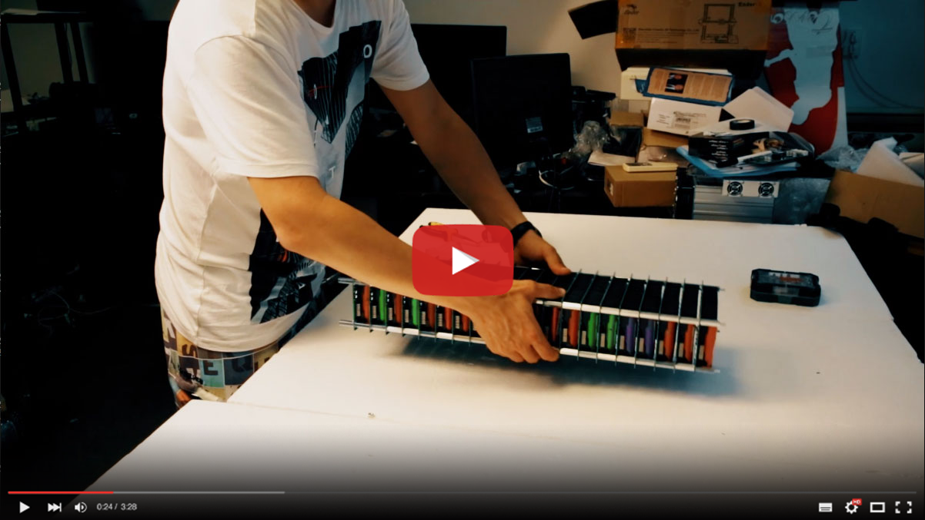
Here’s a photo of his setup:
I asked him to make a video presentation about this setup and share the information with others. And he did, you can watch it here:
>> Video Presentation <<
This device has huge potential to save thousands of dollars each month and you will also learn about a neat solution for recycling used laptop and power tools batteries.
If you are a DIY enthusiast, you cannot miss this free video presentation.
All the best!
Your Name.

Email 3:

Subject: ​Hidden solar technology revealed after 20 years

​Hi,
The following video shocks you!
Hidden technology has surfaced from the bottom of the ocean.
A scuba diver working for US government stole the patents
of a nano solar cell (half of an inch square), capable of generating
the same amount of electricity as a full-size solar panel.
Check out the following free video presentation to learn what is all about:
>> Watch Now! <<

Email 4:

Subject: ​ A US diver found the secret to a new electricity source

​Hi,
Brian was a diver that disappeared 20 years ago, before his disappearance, he left
behind the plans for a new type of solar cell found on a sunken military vessel.
The half of the inch square solar cell produces the equivalent electricity of a
regular size solar panel.
>> See the full story here <<
His nephew continued his legacy, and now it’s transforming it into
a worldwide phenomenon, giving access to everyone to cheap electricity.
Watch This Video for more information.
All the best!
Your NAME.

Email 5:

Subject: ​ This crazy guy revealed all the battery secrets in the industry

​Hi,
Have you ever wondered why portable devices are so cheap? Vacuum cleaners, flashlights, power tools, you name it.
Let me tell you the truth…
The truth is that manufacturers found a way to make us pay more for batteries.
They are using pretty good components for the tool, but they install cheap batteries that stop working after a few cycles.
Watch this free video presentation to get the entire story and discover a hidden secret that will allow you to repair any battery.
There are millions of devices that are being thrown away every day because their battery died.
This massive pile of devices is a gold mine for those who know how to fix and recover batteries.
This video will enlighten you.
Watch it here >>

